3. ReactJS-HOL

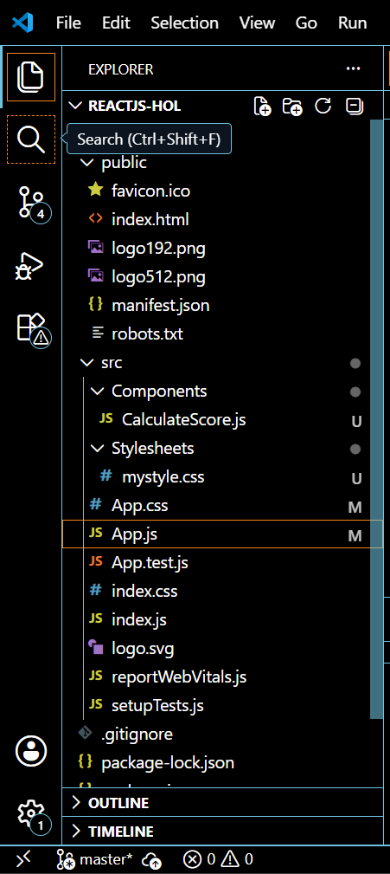

CalculateScore.js
import '../Stylesheets/mystyle.css';
const percentToDecimal = (decimal) => {
return (decimal.toFixed(2) + "%");
};

const calcScore = (total, goal) => {
return percentToDecimal(total / goal);
};

export const CalculateScore = ({ Name, School, total, goal }) => {
return (
<div className="formatstyle">
<h1><font color="brown">Student Details:</font></h1>

<div className="Name">
<b><span>Name:</span> </b>
<span>{Name}</span>
</div>

<div className="School">
<b><span>School:</span> </b>
<span>{School}</span>
</div>

<div className="Total">
<b><span>Total:</span> </b>
<span>{total}Marks</span>
</div>

<div className="Score">
<b><span>Score:</span> </b>
<span>
{calcScore(total, goal)}
</span>
</div>
</div>
);
};

mystyle.css
.Name {
font-weight: 300;
color: blue;
}

.School {
color: crimson;
}

.Total {
color: darkmagenta;
}

.formatstyle {
text-align: center;
font-size: large;
}

.Score {
color: forestgreen;
}

App.js
import { CalculateScore } from './Components/CalculateScore';

function App() {
return (
<div>
<CalculateScore
Name="Steeve"
School="DNV Public School"
total={284}
goal={33}
/>
</div>
);
}
export default App;

OUTPUT:
